# 🧪 HTTPs Test Script Recorder in JMeter

This component records your browser/app's HTTP/HTTPS traffic and generates HTTP samplers in JMeter.

**🔧 Global Settings**

* **Port: 8888**
  + 📌 The proxy port JMeter listens on.
  + 🔍 *Example:* When set to 8888, configure your browser to use localhost:8888 as the proxy.
* **HTTPS Domains:** *(optional)*
  + 📌 List of domains to record HTTPS traffic from.
  + 🔍 *Example:* Add example.com to only record secure traffic from that domain.

**🗂️ Tabs**

* **Test Plan Creation**
* **Requests Filtering**
  + 🔁 Switch between configuration options.

**🧩 Test Plan Content**

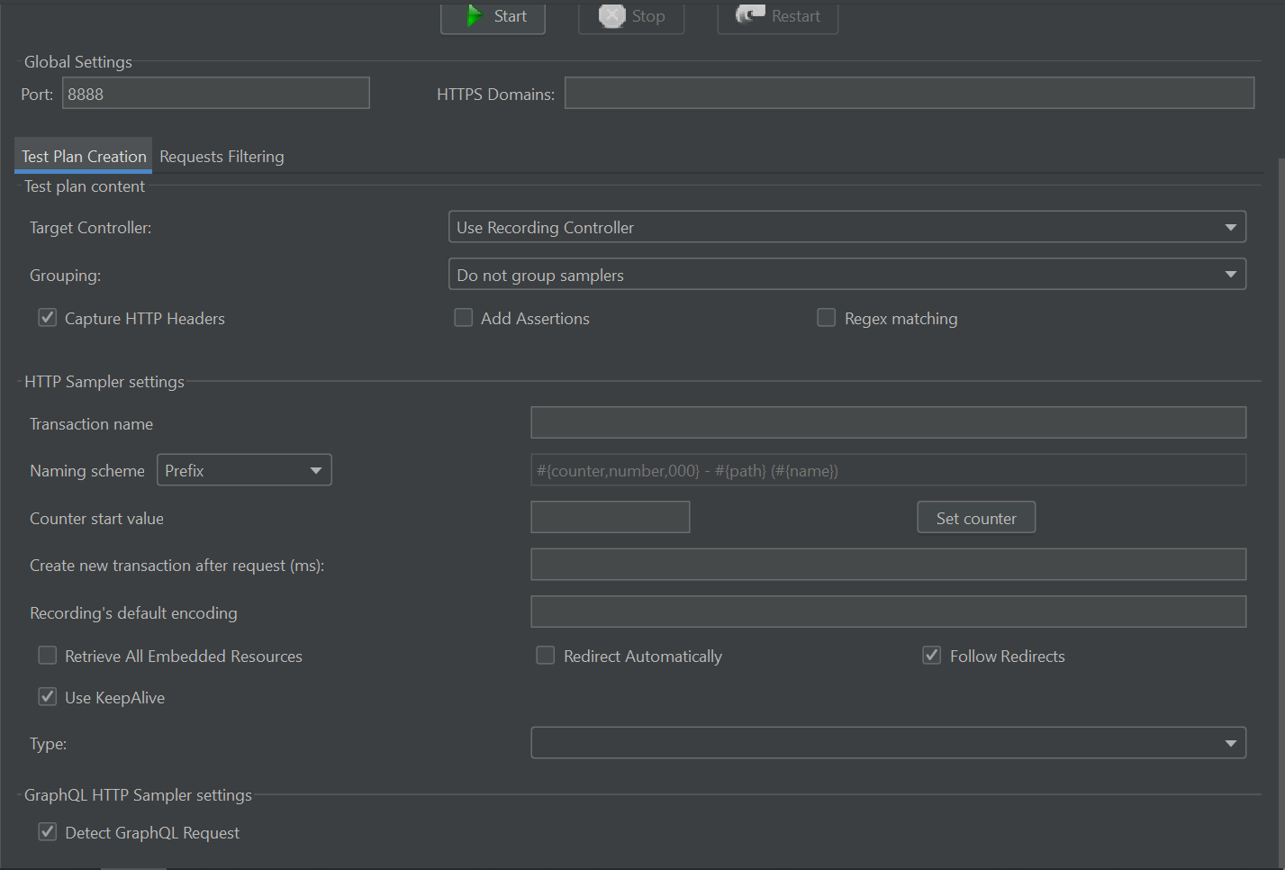

* **Target Controller: Use Recording Controller**
  + 📌 Defines where to store recorded samplers.
  + 🔍 *Example:* Use a Recording Controller in your Test Plan to organize traffic.
* **Grouping: Do not group samplers**
  + 📌 How to organize recorded requests.
  + 🔍 *Example:* Choose "Group by controller" to group all requests to the same URL path.
* ✅ **Capture HTTP Headers**
  + 📌 Include headers like User-Agent, Authorization in requests.
  + 🔍 *Example:* Useful when headers are critical for session validation.
* ⬜ **Add Assertions**
  + 📌 Automatically attach assertions like “Response Code = 200”.
  + 🔍 *Example:* Add to catch unexpected server errors.
* ⬜ **Regex Matching**
  + 📌 Use regex to filter or group samplers.
  + 🔍 *Example:* Group all URLs that start with /api/*.

**🧾 HTTP Sampler Settings**

* **Transaction Name:** *(optional)*
  + 📌 Logical name for a recorded transaction.
  + 🔍 *Example:* "Login Transaction"
* **Naming Scheme: Prefix**
  + 📌 Prepend a prefix to each sampler name.
  + 🔍 *Example:* “Recorded-LoginPage”, “Recorded-Dashboard”
* **Counter Start Value:** *(optional)*
  + 📌 Start number for counter-based naming.
* **Create new transaction after request (ms):** *(optional)*
  + 📌 Split requests into new transactions after this delay.
  + 🔍 *Example:* If delay > 1000ms, treat next request as a new transaction.
* **Recording's Default Encoding:** *(optional)*
  + 📌 Specify character encoding like UTF-8.
* ✅ **Retrieve All Embedded Resources**
  + 📌 Automatically downloads images, CSS, JS from HTML pages.
  + 🔍 *Example:* Enables simulating full page loads.
* ✅ **Use KeepAlive**
  + 📌 Use persistent HTTP connections.
  + 🔍 *Example:* Simulates real browser behavior.
* ⬜ **Redirect Automatically**
  + 📌 Follows HTTP 3xx redirects.
  + 🔍 *Example:* Important for login flows with redirection.
* ✅ **Follow Redirects**
  + 📌 Similar to above, but allows assertions on initial response.
* **Type:** *(dropdown not shown)*
  + 📌 Lets you define sampler type if using a custom plugin or method.

**🔗 GraphQL HTTP Sampler Settings**

* ⬜ **Detect GraphQL Request**
  + 📌 Enables detection and handling of GraphQL queries/mutations.
  + 🔍 *Example:* Required for modern web apps using GraphQL.

**🔎 Requests Filtering**

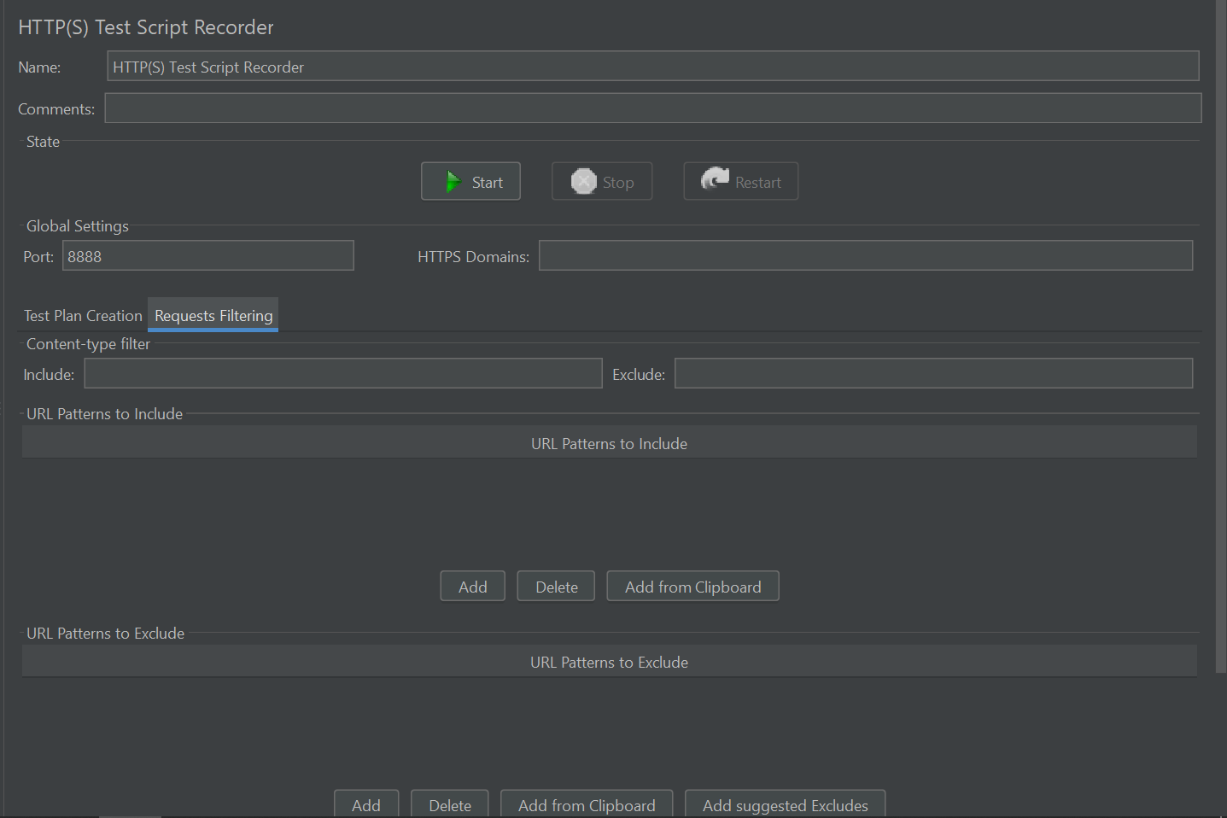

**📄 Content-Type Filter**

* **Include / Exclude:** *(Text-based content filtering)*
  + 🔍 *Example:* Include text/html, exclude image/* to avoid noise.

**🌐 URL Patterns to Include**

* 📌 Add regex-based URL patterns to include.
  + 🔍 *Example:* .*\.php → record only PHP page requests.

Buttons:

* **Add / Delete / Add from Clipboard**

**🚫 URL Patterns to Exclude**

* 📌 Define patterns to **skip** recording.
  + 🔍 *Example:* .*\.png, .*\.css, .*\.js

Buttons:

* **Add / Delete / Add from Clipboard / Add Suggested Excludes**
  + 🔍 *Tip:* Use **"Add Suggested Excludes"** to quickly skip static resources.

**👂 Notify Child Listeners of Filtered Samplers**

* ⬜ Optional checkbox to notify listeners even for excluded samplers.
  + 🔍 *Example:* Can be useful for debugging or capturing failures.

# 🛡️ Setting Up JMeter HTTPS Recording

When you record **HTTPS** traffic in JMeter, it acts as a proxy. For it to read encrypted traffic (SSL/TLS), your browser must trust the **JMeter Root CA Certificate**.

**🧾 Why is a JMeter Certificate Needed?**

* JMeter works as a **Man-in-the-Middle (MITM)** to record HTTPS requests.
* It must **decrypt encrypted traffic**—for that, it uses a temporary Root Certificate.
* Browsers block this unless they **explicitly trust JMeter’s certificate**.

**🧪 Step 1: Generate the JMeter Root Certificate**

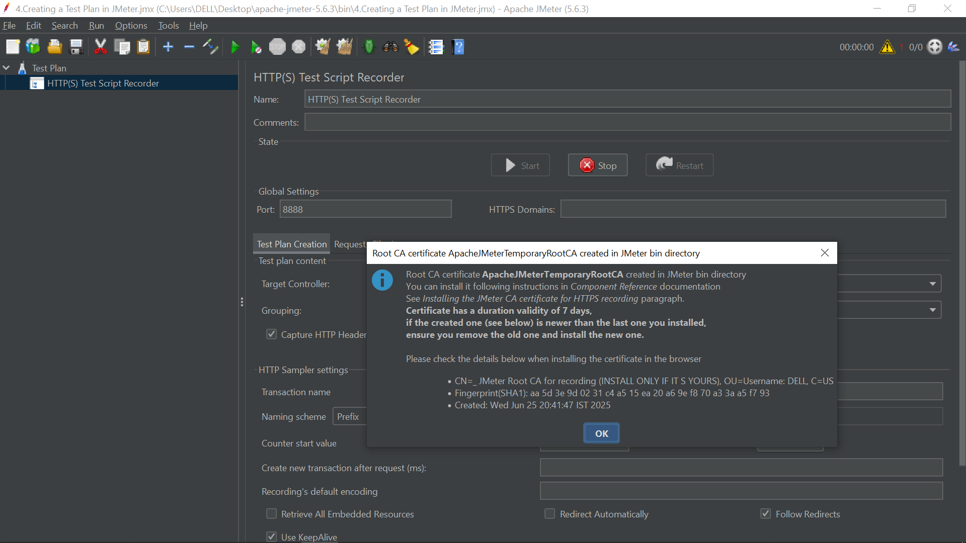

✅ **Automatic on first use!**

* Launch JMeter:  
  jmeter.bat (Windows) or jmeter.sh (Linux/macOS)
* Navigate:  
  Test Plan → Add → Non-Test Elements → HTTP(S) Test Script Recorder
* 🔃 Click **Start**  
  → You’ll see a message like:  
  *“Root CA certificate: ApacheJMeterTemporaryRootCA.crt generated in JMeter bin directory”*

📂 **Find the Certificate:**  
Go to: JMETER_HOME/bin/ApacheJMeterTemporaryRootCA.crt

**🌐 Step 2: Install the Certificate in Your Browser**

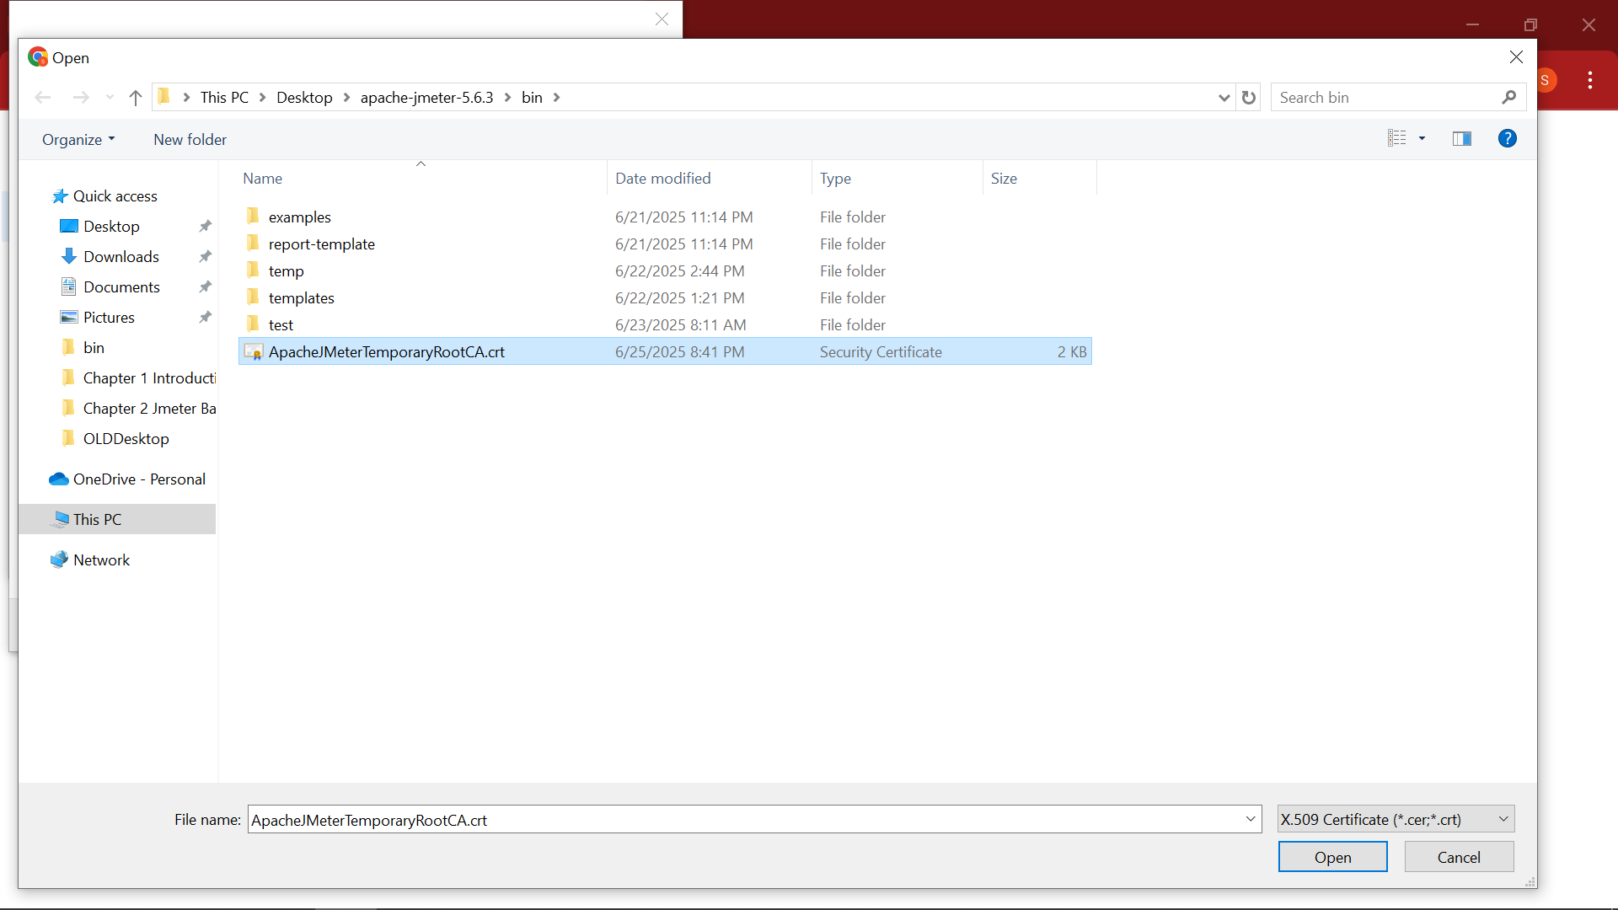

**🔵 A. For Chrome / Edge (Windows/macOS)**

🧭 Use **OS certificate store** for both.

1. Go to: **Settings → Privacy & Security → Security → Manage Certificates**
2. In "Trusted Root Certification Authorities", click **Import**
3. Browse to ApacheJMeterTemporaryRootCA.crt
4. Complete the wizard and click **Yes** to trust
5. ✅ **Verify**: Certificate should show up in the trusted root list
6. 🔄 Restart the browser

**🦊 B. For Firefox (has its own store)**

1. Go to: **Settings → Privacy & Security → Certificates → View Certificates**
2. Click **Authorities → Import**
3. Select ApacheJMeterTemporaryRootCA.crt
4. ✅ Check:
   * ✅ Trust this CA to identify websites
   * (Optional) Email/dev verification
5. 🔄 Restart Firefox

**🌐 Step 3: Configure Browser Proxy to Route via JMeter**

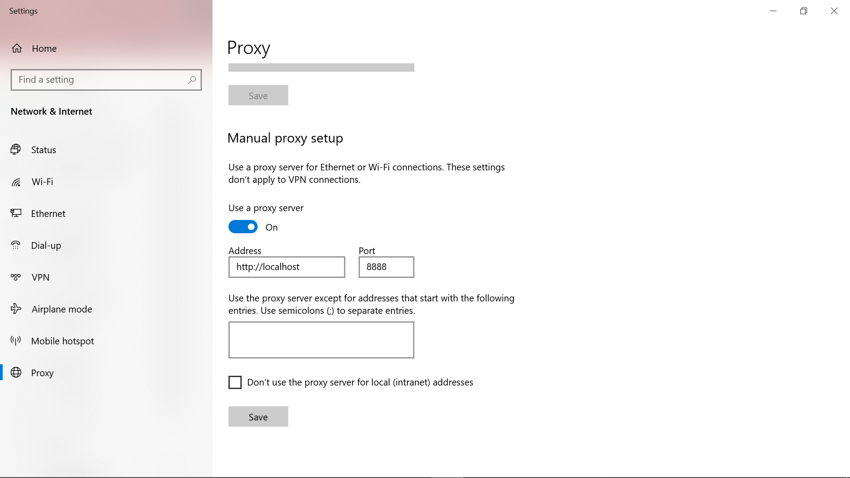

🔧 Let JMeter capture browser traffic!

**Port:** Usually 8888 (Check in HTTP(S) Test Script Recorder)

**⚙️ Chrome / Edge (uses system proxy):**

**Windows:**

1. Go to: Settings → Network & Internet → Proxy
2. Enable Manual Proxy
   * **Address:** localhost
   * **Port:** 8888

**macOS:**

1. Go to: System Settings → Network → [Active Connection] → Proxies
2. Enable:
   * Web Proxy (HTTP) → localhost : 8888
   * Secure Web Proxy (HTTPS) → localhost : 8888

✅ Save the changes.

**🦊 Firefox (custom proxy settings):**

1. Go to: Settings → General → Network Settings → Manual Proxy Configuration
2. Enter:
   * HTTP Proxy: localhost, Port: 8888
   * SSL Proxy: localhost, Port: 8888
3. ✅ Check: *Use this proxy server for all protocols*
4. Click OK

**📲 Step 4: Start Recording in JMeter**

1. Open **HTTP(S) Test Script Recorder**
2. ✅ Click **Start**
3. 🌐 Open your browser and **interact with your app**
4. ✅ JMeter captures actions as **HTTP Samplers**
5. 🟥 When done, click **Stop**
6. 🧹 Reset proxy settings in the browser/system

**🎯 Example Scenario**

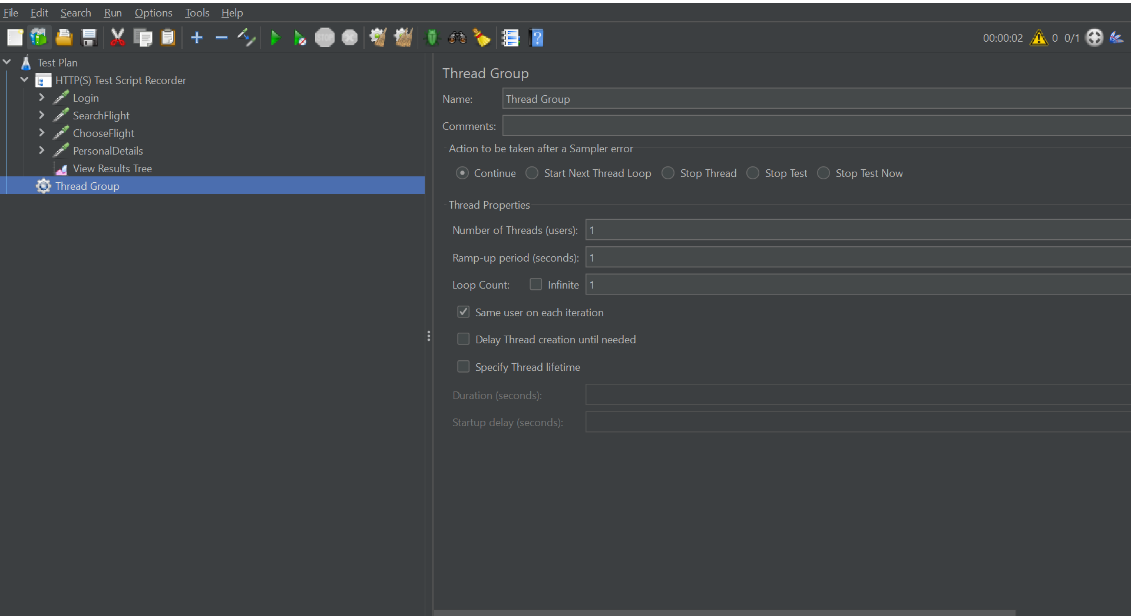

**Goal:** Record login flow of https://example.com

✅ Steps:

* Open browser (proxy on)
* Visit https://example.com
* Log in with test credentials
* JMeter records:
  + GET /login
  + POST /authenticate
  + GET /dashboard

➡️ Samplers are captured under **Recording Controller**